# Written Report for “Analysis of bird survey data to refine monitoring designs and survey protocols” (EC Contract No. 3000704376)

By Lionel Leston

# Introduction

In recent decades, many landbird species have experienced continued long-term population declines across Canada and North America (Rosenberg et al. 2019), based on data from broad-scale, all-bird monitoring programs like the North American Breeding Bird Survey (hereafter, “BBS”) (Sauer et al. 1994). As a result, several species are listed on Schedule 1 of Canada’s Species-at-Risk Act (SARA). Aerial insectivores like the Common Nighthawk (*Chordeiles minor*) (hereafter, “CONI”) are one of the most strongly declining groups (Canaday 1997, Sekercioglu et al. 2002, Nebel et al. 2010, Hallman et al. 2014, Paquette et al. 2014, Smith et al. 2015). For several species including crepuscular aerial insectivores like the CONI, their habitat preferences or activity periods are likely mismatched with current protocols such as those of the BBS. The methods of the BBS are designed to maximize the detection of diurnal songbird species, many of which can be detected within the 3-minute count periods used by the BBS. In contrast, the crepuscular CONI is likely to be more active and detectable at times when songbirds are less active, so its occupancy and abundance may be poorly represented within existing all-bird surveys like the BBS. Inaccurate estimates of occupancy and abundance could result in unreliable population distribution, trend estimates, and recommendations for this species’ recovery. The Canadian Wildlife Service (Ontario Region) (CWS-ON) has conducted several pilot surveys and research projects in recent years with the goal of evaluating and improving survey protocols for species with low data precision.

# Objectives

* Run occupancy models with detection covariates to assess which variables most strongly affect probability of detection of CONI across Canada.
* Determine optimal recording length and number of recordings to reliably detect CONI that are present.
* Assess accuracy of model predictions of CONI presence/absence (e.g. receiver-operating characteristic [ROC] curves, rates of false positive detections).
* Run generalized additive mixed models to determine how CONI call rates (booms and peent calls) vary with ordinal day and time since sunrise.
* After determining optimal survey design for CONI, compare and contrast this survey design to BBS protocols to show how protocols might be adjusted to increase CONI detection.

# Methods

## Recordings

Nocturnal bird surveys focusing on CONI were conducted from June 1 to August 28, 2014 at 23 sites (1-3 sites at each of 12 general locations spanning 3000 km from Ottawa, ON (45°21 N, -76°0 W) to Yellowknife, NT (62°42 N, -116°6 W)) using autonomous recording units (ARUs). Sites within general locations were ≥ 1.8 km apart to minimize the probability of double-counting individual CONI at different sites. Sites were selected opportunistically, coinciding with other projects conducted by colleagues and volunteers. Sites were also selected based on their *a priori* suitability as CONI habitats (e.g. extensive openings with sand, gravel or rock; recently burned or harvested areas (Brigham et al. 2011)), as determined from mapped imagery or by biologists in the field deploying ARUs in the areas.

CONI sounds include low-frequency (0.4-1.0 kHz) “booms” made by flexing the wings at the bottom of an aerial dive. These booms are made presumably by males at dawn and dusk by males to maintain and defend discreet aerial territories (Weller 1958, Brigham et al. 2011), often over habitat features used for feeding or breeding (Caccamise 1974). Another more common vocalization is a mid-frequency contact call or "peent" (2-4 kHz), used for territorial displays, defensive threats, and courtship (Brigham et al. 2011). Patterns in both sound types were analyzed separately from each other, since booms and peents appear to be associated with different behaviours and functions and since detection of one sound type might be differently affected by environmental variables from the other sound type.

Nighthawk activity was measured using Song Meter ARUs (Model SM2+, Wildlife Acoustics Inc., Maynard, MA; firmware version 3.2.5) ARUs. ARUs were deployed in late May or early-June at all locations and retrieved from mid-July to mid-August, and were programmed to record continuously from 1-hr before sunset to 1-hr after sunrise local time at each site, starting 1 June 2014; the same recording program was repeated on a 4-day interval throughout the breeding season or until ARUs were retrieved. Nighthawk sounds are typically low frequency and given the large number of recordings required, ARUs were programmed to record at a sampling rate of 16 kHz and a bit depth of 16 bits to conserve battery power. Files were saved in the uncompressed waveform audio file (.wav) format. A single 32 GB and a single 16 GB SD memory card (48 GB total) were used together in each ARU to store all acoustic files within ARUs, with standard alkaline batteries installed in units prior to deployment.

Two partially-automated approaches were used to obtain data from acoustic recordings. First, peent vocalizations were obtained using an automated time-frequency band-limited energy detector (BLED; see Mills 2000), in Raven Pro (version 1.4; Charif et al. 2010). Frequency range and time durations used to parameterize the detector were defined based on a random sampling of 100 peents from our recordings. For the remaining detector parameters, settings were adjusted as necessary from default settings to find the best configuration for isolating "peent" vocalizations. After running the detector, the resulting list of candidate peent detections was verified manually for accuracy. False positives were scored as 0 and true positives were scored as 1 in the resulting output file.

Second, a visual scanning approach was used to count non-vocal "booms" by viewing spectrograms in Raven Pro. Using the timed auto page-advance function, 1-min recordings were viewed and rapidly assessed, enabling processing of an hour’s recordings in approximately 1 min, depending on the frequency of nighthawk booming. The analyst initially audibly confirmed each visually detected candidate "boom" until candidate signals could be confidently confirmed using only visual detection. When a "boom" was confirmed on a recording, the timed auto-page advance function was paused and the signal was selected by drawing a box around it, capturing the start time (in seconds since the beginning of the recording), duration, and frequency range.

## Converting Continuous Recording Data to Interval Data

Continuous recorded data for each site included the date and start and end times of each recording, and the time (seconds after the start of the recording) when either peents or booms were detected. Each recording began 1 hour before local sunset and ended 1 hour after local sunrise. The **suncalc** package in R (Agafonkin and Thieurmel 2017) was used to estimate the start and end of civil, nautical, and astronomical twilight periods 1 and 2 as well as the “night” twilight period between astronomical twilight 1 and astronomical twilight 2.

I used the **lubridate** package in R (Grolemund and Wickham 2011) to break down each night’s single recording at each site into intervals of specific duration. I used durations ranging from 1 minute to 20 minutes in 1-minute increments to create a range of interval times including those periods typically used in bird surveys across studies, along with 1-hour intervals. Each time I broke a continuous recording down into specific intervals, I saved the results in a separate CSV file (“*0_data/ processed/1_IntervalUsed*”).

*Assigning Specific Detection Events and Other Data to Specific Time Intervals*

I assigned peents and booms to specific time intervals separately. After using the **lubridate** package to calculate the date-time of a specific detection event based on the event’s time in a recording, I used the **intrval** package in R (Sólymos 2017) to map individual detection events from a given site and date to a specific time interval within that site’s and date’s recording. Specific time intervals that lacked any detection events were assigned “NA” values. I looped through the 21 specific interval files, mapping detection events to 21 mapped interval files for each kind of CONI vocalization (“*0_data/processed/2_BoomDetectionsMapped*”, “*0_data/processed/2_PeentDetectionsMapped*”).

Once specific intervals were assigned detections or no detections, I used the **lubridate** package to determine time since sunset (hereafter, “TSSS”) for the start time of each interval. I used the **suncalc** package to determine the moon fraction (ranging from “new moon” = 0 to “full moon” = 1) as a measure of moon illumination that might influence CONI activity through the amount of moonlight when foraging. I assigned specific intervals to “Twilight Period” based on the intervals’ times within the recording relative to the twilight period times at a given site on a given day, using the categories “Before”, “Civil”, “Nautical”, “Astronomical”, “Night”, and “After”. Finally, I assigned mean nightly temperature to intervals for those dates when temperatures had been taken at each site (“*0_data/processed/3_BoomsMapped_SunAndMoon*”, “*0_data/processed/3_PeentsMapped_SunAndMoon*”).

## Sampling from Intervals

To create data sets for testing the effects of sample size and sample duration on CONI detection probability, I randomly drew all observations from different numbers of intervals at each site across the whole season, from each of the interval files with mapped detections, TSSS, twilight period and temperature. For a given interval duration, I randomly sampled 1, 2, and 3 intervals from each site from any time in the season. For larger sample sizes (4, 8, 12, 16, 20, 24, 28, and 32 intervals), I stratified the intervals files by creating half-month-long sampling periods, then randomly sampled 1, 2, 3, 4, 5, 6, 7, and 8 samples per half-month period between June 1 and July 31. I excluded all recordings from August because CONI activity was determined to be negligible by that time. I also excluded all sites missing nightly mean temperature data. Finally, I excluded sampling from any intervals that were less than the specified interval duration within a given file. Such intervals occurred because each continuous nightly recording could not be perfectly divided into intervals of the same duration. Each sample was stored in a separate file (“*0_data/processed/4_NSampleBooms*”, “*0_data/processed/4_NSamplePeents*”).

## Assessing Probability of Detection With Occupancy Models

For each sampled data set combination of sample number per site and sample duration, I ran single-season occupancy models with the **unmarked** package in R (Fiske and Chandler 2011) to measure the probability of detecting CONI within a given interval and how detection probability varied with TSSS, ordinal day (# days since January 1), latitude, mean nightly temperature, and moon fraction. I ran separate sets of occupancy model analyses using 1) peent detections as the response variable, then 2) boom detections as the response variable.

I built up occupancy models for each sampled data set in five stages, adding new variables to the best model from the previous stage. I ranked the “best” model at each stage as having the lowest AIC statistic (Burnham and Anderson) and passed the best model to the next stage using the **MuMIn** package in R (Barton and Barton 2019). Since I focused on variables affecting detection probability rather than occupancy, I assumed equal occupancy among sites in this analysis. Stages were as follows:

Stage 1: Null model: *ψ ~ 1; P ~ 1*

Latitude model: *ψ ~ 1; P ~ Latitude*

TSSS model: *ψ ~ 1; P ~ Time Since Sunrise (s)*

TSSS quadratic model: *ψ ~ 1; P ~ Time Since Sunrise + (Time Since Sunrise)2*

TSSS*latitude model: *ψ ~ 1; P ~ Time Since Sunrise + Latitude + Time Since Sunrise*Latitude*

TSSS*latitude quadratic model: *ψ ~ 1; P ~ Time Since Sunrise + Latitude + (Time Since Sunrise)2 + Time Since Sunrise*Latitude + (Time Since Sunrise)2*Latitude*

Stage 2: Null model: *ψ ~ 1; P ~ 1*

Ordinal day model: *ψ ~ 1; P ~ Days Since Jan 1 (d)*

Ordinal day quadratic model: *ψ ~ 1; P ~ Days Since Jan 1 + (Days Since Jan 1)2*

Ordinal day*latitude model: *ψ ~ 1; P ~ Days Since Jan 1 + Latitude + Days Since Jan 1 *Latitude*

Ordinal day*latitude quadratic model: *ψ ~ 1; P ~ Days Since Jan 1 + Latitude + (Days Since Jan 1)2 + Days Since Jan 1*Latitude + (Days Since Jan 1)2*Latitude*

Stage 3: Best stage 1 model

Best stage 2 model

TSSS *+* Ordinal day model: *ψ ~ 1; P ~ Best stage 1 model + Days Since Jan 1 (d)*

TSSS *+* Ordinal day quadratic model: *ψ ~ 1; P ~ Best stage 1 model + Days Since Jan 1 + (Days Since Jan 1)2*

TSSS *+* Ordinal day*latitude model: *ψ ~ 1; P ~ Best stage 1 model + Days Since Jan 1 + Latitude + Days Since Jan 1 *Latitude*

TSSS *+* Ordinal day*latitude quadratic model: *ψ ~ 1; P ~ Best stage 1 model + Days Since Jan 1 + Latitude + (Days Since Jan 1)2 + Days Since Jan 1*Latitude + (Days Since Jan 1)2*Latitude*

Stage 4: Best stage 3 model

Temperature model: *ψ ~ 1; P ~ Best stage 3 model + Mean Nightly Temperature (°C.)*

Stage 5: Best stage 4 model

Moon Illumination model: *ψ ~ 1; P ~ Best stage 3 model + Moon Fraction (0-1)*

I stored model coefficients and test statistics from the occupancy models run for each sample data set (“*0_data/processed/5_NSampleBooms_OccupancyModels*”, “*0_data/processed /5_NSamplePeents_OccupancyModels*”), and stored the best occupancy model for each sample data set as observations in a spreadsheet (“*3_output/tables/5_NSampleBooms_OccupancyModels*”, “*3_output/tables/5_NSamplePeents_OccupancyModels*”).

I used the final “best” model to predict probability of occupancy (*ψ*), probability of detection given occupancy (*P*), and the joint detection probability of *ψ*P* on each visit. I compared joint detection probability to actual detection or not from each visit to each site, using receiver-operating characteristic (ROC) curves and calculated area-under-the-curve (AUC) as a way of validating model accuracy (Robin et al. 2011). I considered an AUC value of 0.7 or higher to indicate model adequacy at predicting detection/non-detection. I generated ROC curves for each combination of sample size and duration (“*3_output/figures/5A_PeentOccupancyModelROCPlots*”, “*3_output/figures/5B_BoomOccupancyModelROCPlots*”).

I also estimated the proportion of sites with at least 1 detection among visits and mean detection probability across all visits within each sampled data set and stored those variables with that data set’s AUC statistic, sample size and duration as observations in a spreadsheet (“*3_output/tables/5_NSampleBooms_OccupancyModels*”, “*3_output/tables/5_NSamplePeents_OccupancyModels*”). I then graphed those observations within 3-dimensional plots to examine how AUC and mean detection probability varied with sample size and duration (“*3_output/figures/5A_PeentOccupancyModel3DPlots*”, “*3_output/figures/5B_BoomOccupancyModel3DPlots*”).

I examined the occupancy models for the data set with 20 1-hour visits per site from the peent analyses and for the data set with 20 1-hour visits per site from the boom analyses. I compared predictors in the top occupancy models for these data sets to the predictors in top occupancy models for the same numbers of 3-minute visits (length of a BBS point count [Sauer et al. 1994]), 6-minute visits (used in CONI monitoring), 10-minute visits and 15 visits (length of recordings used in multiple ARU-based nocturnal bird surveys [Buxton and Jones 2012, Tegeler et al. 2012, Frommolt and Tauchert 2014, Oppel et al. 2014, Frommolt 2017]). I estimated probability of detection given that a site was occupied based on each top occupancy model and the data used to generate that model and visualized the estimates within 3-dimensional plots.

## Assessing Activity Rates with Generalized Additive Mixed Models

To examine how activity rates (number of peents or booms counted per interval) varied with ordinal day and TSSS for sites occurring at different latitudes, I used the **gamm4** package in R (Wood et al. 2017) to run a generalized additive mixed model (GAMM) to select the likeliest nonlinear functions of ordinal day and TSSS that fit the data. Based on exploration of raw count data, I split sites into two groups by latitude (LatgroupN: “North” ≥ 55 degrees, “South” < 55 degrees) since at that latitude the length of both nightly recordings and the survey season was significantly shorter at the northern sites.

Each GAMM was modelled using a negative binomial error distribution in which I specified the amount of overdispersion relative to a Poisson distribution (theta). The GAMM took the following form:

Count ~ LatgroupN + s(TSSS, k=4, bs=”cs”, by=LatgroupN) + s(Ordinal day, k=4, bs=”cs”, by=LatgroupN)

I used “site” as a random effect to account for correlations due to repeated visits from the same sites. I specified a nonlinear function with up to 4 knots or change points, to be connected by cubic splines.

I ran GAMMs for the data set with 20 1-hour visits per site from the peent analyses and for the data set with 20 1-hour visits per site from the boom analyses. I compared predictors in the top occupancy models for these data sets to the predictors in top occupancy models for the same numbers of 3-minute visits (length of a BBS point count), 6-minute visits (used in CONI monitoring), 10-minute visits and 15 visits (length of recordings used in multiple ARU-based nocturnal bird surveys). I estimated peent and boom activity rates using this GAMM with each data set and visualized the estimates within 3-dimensional plots.

# Results

*Assessing Probability of Detection With Occupancy Models*

## Effect of Number of Visits and Visit Duration on Detection

After generating the samples, I found that log(proportion of sites with at least one peent detection per visit) increased with both number of visits and sample duration (βnumber of visits=0.0627, S.E.=0.0064, p<0.0001; βvisit duration=0.00035, S.E.=0.00009, p=0.0002; Adjusted *R*2=0.3183), reaching an asymptote at 20 visits/site. For the occupancy model results, after excluding results from data sets with <3 visits per site, log(mean detection probability for peents) was correlated with increasing duration but not number of visits (βnumber of visits=0.0013, S.E.=0.0028, p=0.6270; βvisit duration=0.0005, S.E.=0.00003, p<0.0001; Adjusted *R*2=0.4667), and peent detection probability was highest for 1-hour intervals. Area-under-the-curve of the top peent occupancy model for each data set was not correlated with increasing duration, and decreased slightly with increasing number of visits (βnumber of visits=-0.0025, S.E.=0.0011, p=0.0340; βvisit duration=0.000005, S.E.=0.000016, p=0.7310; Adjusted *R*2=0.0142), dropping sharply above 4 visits per site (Figures 1-3).

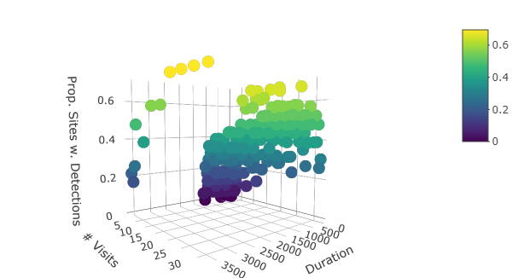

### Figure 1. Proportion of sites with at least 1 peent detection in the samples versus number of visits per site (1-4, 8, 16, 20, 24, 28, 32) and duration of visit (seconds).

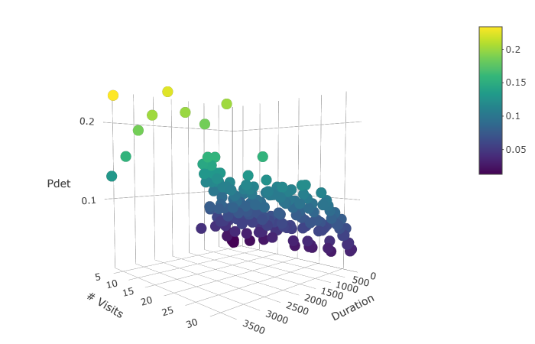

### Figure 2. Mean peent detection probability predicted per visit versus number of visits per site (1-4, 8, 16, 20, 24, 28, 32) and duration of visit (seconds).

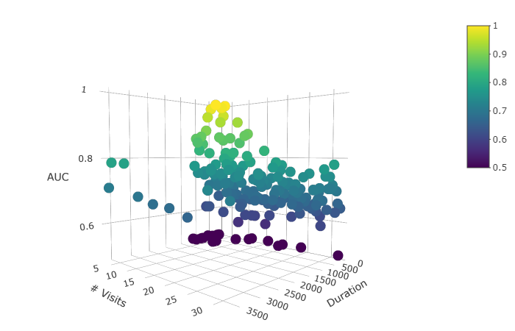

### Figure 3. Area under the curve (AUC), a measure of peent call prediction accuracy for the “best” occupancy model for each sample data set versus number of visits per site (1-4, 8, 16, 20, 24, 28, 32) and duration of visit (seconds) in each sample data set. I considered AUC>0.7 to indicate an acceptable model in terms of prediction accuracy.

Log(proportion of sites with at least one boom detection per visit) increased with both number of visits and sample duration (βnumber of visits=0.0160, S.E.=0.0007, p<0.0001; βvisit duration=0.00007, S.E.=0.00001, p<0.0001; Adjusted *R*2=0.7208), reaching an asymptote at 12 visits/site. For the occupancy model results, after excluding results from data sets with <3 visits per site, the log(mean detection probability for booms) was correlated with increasing duration but not number of visits (βnumber of visits=0.0016, S.E.=0.0024, p=0.5110; βvisit duration=0.0004, S.E.=0.00003, p<0.0001; Adjusted *R*2=0.4949), and boom detection probability was highest for 1-hour intervals. Area-under-the-curve of the top boom occupancy model for each data set was not correlated with increasing duration, and decreased slightly with increasing number of visits (βnumber of visits=-0.0015, S.E.=0.0009, p=0.0854; βvisit duration=0.000017, S.E.=0.000012, p=0.1554; Adjusted *R*2=0.0158), dropping sharply above 4 visits per site (Figures 4-6).

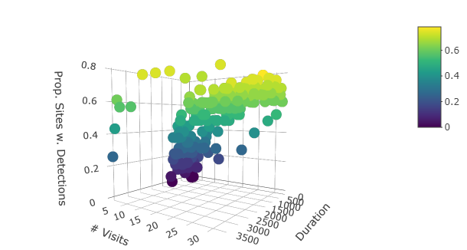

### Figure 4. Proportion of sites with at least 1 boom detection in the samples versus number of visits per site (1-4, 8, 16, 20, 24, 28, 32) and duration of visit (seconds).

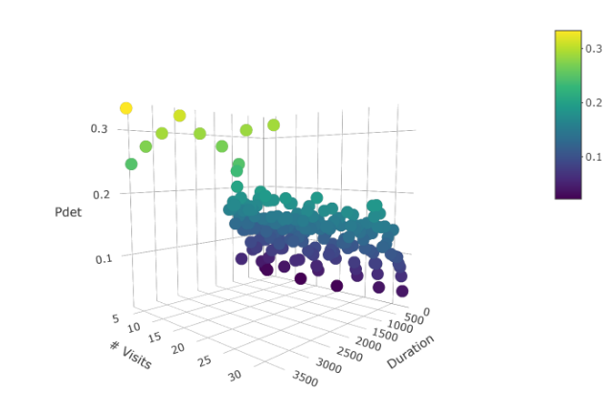

### Figure 5. Mean boom detection probability predicted per visit versus number of visits per site (1-4, 8, 16, 20, 24, 28, 32) and duration of visit (seconds).

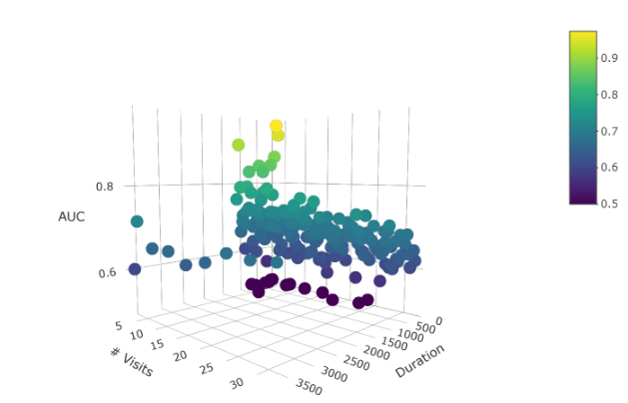

### Figure 6. Area under the curve (AUC), a measure of boom call prediction accuracy for the “best” occupancy model for each sample data set versus number of visits per site (1-4, 8, 16, 20, 24, 28, 32) and duration of visit (seconds) in each sample data set. I considered AUC>0.7 to indicate an acceptable model in terms of prediction accuracy.

## Effects of TSSS, Ordinal Day, Temperature, and Moon Illumination on Peent Detection

When there were 20 3-minute visits per site, probability of peent detection given occupancy declined with increasing ordinal day, and this negative relationship was stronger with increasing latitude. Detection of peents also increased with mean nightly temperature and decreased with increasing moon illumination (Figure 7).

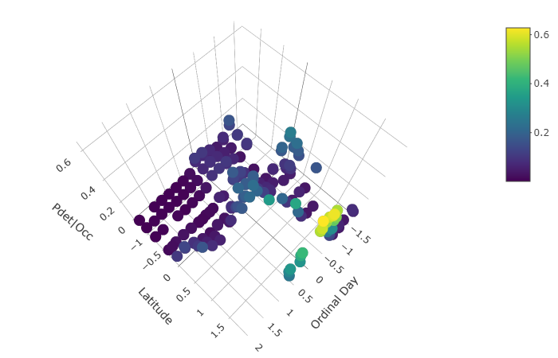 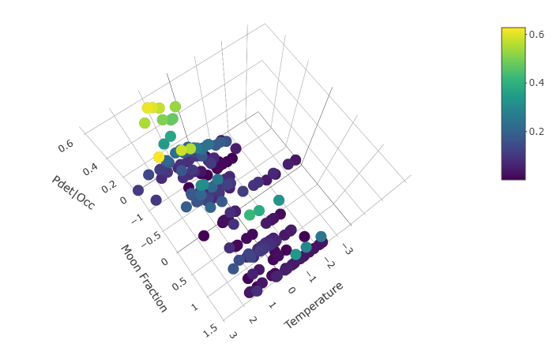

### Figure 7. Predicted peent detection probability given occupancy at a site varying with ordinal day, latitude, moon fraction, and nightly temperature for CONI with 20 visits/site and 180 seconds/visit. Top detection model: Ordinal day (β=-10.63, 95% LCL=-20.09, 95% UCL=-1.18); Latitude (β=-9.98, 95%LCL=-19.79, 95%UCL=-0.17); Ordinal day*Latitude (β=12.83, 95% LCL=1.29, 95% UCL=24.36); Moon fraction (β=-0.60, 95% LCL=-1.24, 95% UCL=0.05); Mean nightly temperature (β=0.35, 95% LCL=-0.36, 95% UCL=1.06).

When there were 20 6-minute visits per site, probability of peent detection given occupancy varied quadratically with TSSS, being highest at/before sunset, lowest at full night and increasing somewhat again at/after sunrise (Figure 8).

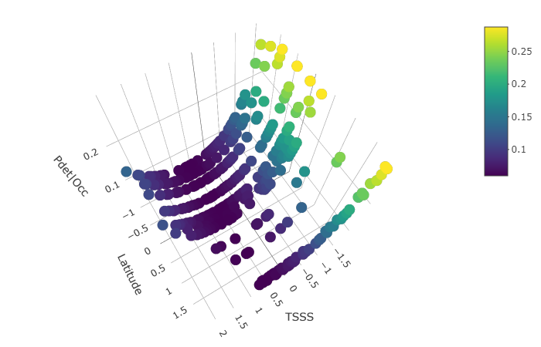

### Figure 8. Predicted peent detection probability given occupancy at a site varying with TSSS (TSSS) for CONI with 20 visits/site and 360 seconds/visit. Top detection model: TSSS (β=-1.39, 95% LCL=-2.60, 95% UCL=-0.18); TSSS2 (β=1.03, 95% LCL=-0.32, 95% UCL=2.38).

When there were 20 10-minute visits per site, probability of peent detection given occupancy declined with increasing TSSS, and this negative relationship was stronger with increasing latitude (Figure 9).

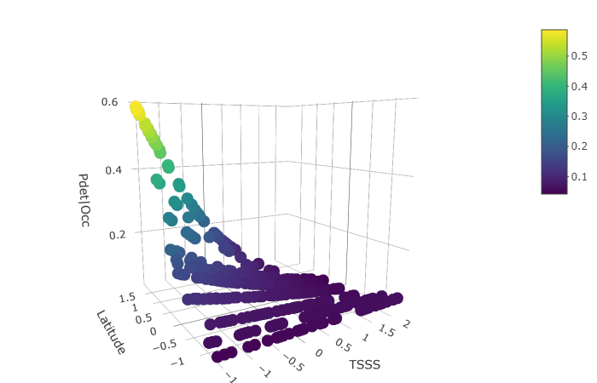

### Figure 9. Predicted peent detection probability given occupancy at a site varying with ordinal day, latitude, moon fraction, and nightly temperature for CONI with 20 visits/site and 600 seconds/visit. Top detection model: TSSS (β=3.27, 95% LCL=-1.43, 95% UCL=7.97); Latitude (β=0.92, 95%LCL=0.35, 95%UCL=1.50); TSSS*Latitude (β=-3.57, 95% LCL=-8.03, 95% UCL=0.89).

When there were 20 15-minute visits per site, probability of peent detection given occupancy probability of peent detection given occupancy declined with increasing ordinal day and increasing TSSS. The negative relationship with ordinal day was stronger with decreasing latitude. Peent detection was less likely with increasing moon illumination (Figure 10).

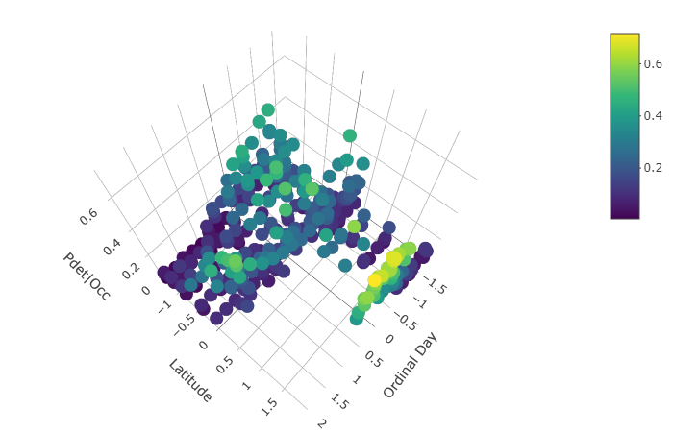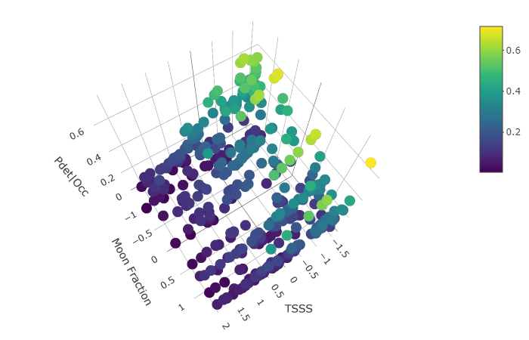

### Figure 10. Predicted peent detection probability given occupancy at a site varying with ordinal day, latitude, moon fraction, and TSSS for CONI with 20 visits/site and 900 seconds/visit. Top detection model: TSSS (β=-0.70, 95% LCL=-1.13, 95% UCL=-0.27); Latitude (β=-8.86, 95%LCL=-15.00, 95%UCL=-2.72); Ordinal day (β=-8.30, 95%LCL=-13.89, 95%UCL=-2.70); Ordinal day*Latitude (β=10.62, 95% LCL=3.52, 95% UCL=17.72); Moon fraction (β=-0.35, 95% LCL=-0.79, 95% UCL=0.08).

When there were 20 1-hour visits per site, probability of peent detection given occupancy was highest at intermediate values of ordinal day (i.e. mid-season), and highest at lower and higher values of TSSS (i.e. closer to sunset and sunrise), but the effect of TSSS varied with latitude. Detection of peents was not strongly predicted by moon illumination or by mean nightly temperature (Figure 11).

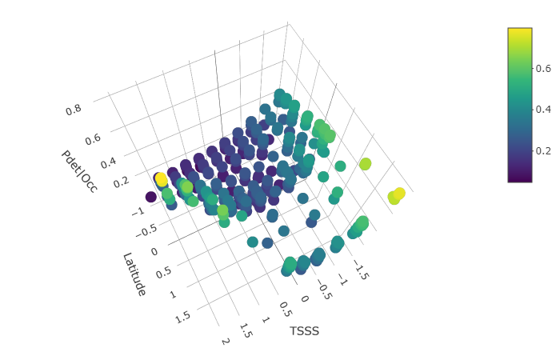 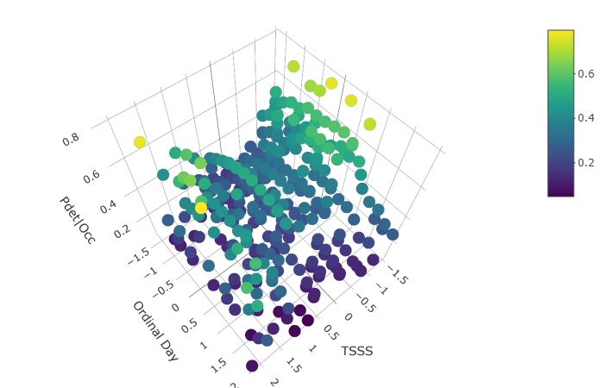

### Figure 11. Predicted peent detection probability given occupancy at a site varying with TSSS, latitude, and ordinal day for CONI with 20 visits/site and 3600 seconds/visit. Top detection model: TSSS (β=2.35, 95% LCL=-5.31, 95% UCL=10.2); TSSS2 (β=-7.24, 95% LCL=-16.64, 95% UCL=2.17); Latitude (β=0.30, 95%LCL=-0.09, 95%UCL=0.70); TSSS*Latitude (β=-3.54, 95% LCL=-10.90, 95% UCL=3.81); TSSS2*Latitude (β=8.27, 95% LCL=-0.79, 95% UCL=17.33); Ordinal day (β=5.99, 95% LCL=-0.23, 95% UCL=12.21); Ordinal day2 (β=-6.14, 95% LCL=-12.41, 95% UCL=0.12).

## Effects of TSSS, Ordinal Day, Temperature, and Moon Illumination on Boom Detection

When there were 20 3-minute visits per site, probability of boom detection was best predicted by latitude without other predictors and was higher at sites at higher latitudes. When there were 20 6-minute visits per site, probability of boom detection given occupancy was highest at intermediate values of ordinal day (i.e. mid-season), and varied quadratically with TSSS, being highest at/near sunset and secondarily at/near sunrise (Figure 12).

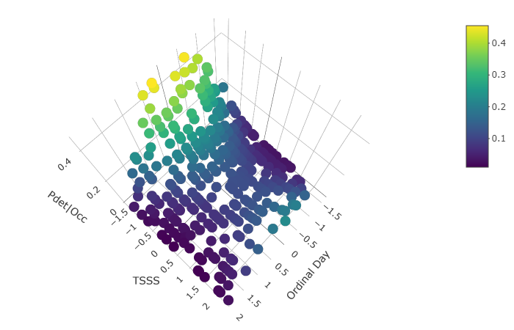

### Figure 12. Predicted boom detection probability given occupancy at a site varying with TSSS and ordinal day for CONI with 20 visits/site and 360 seconds/visit. Top detection model: TSSS (β=-1.48, 95% LCL=-2.53, 95% UCL=-0.43); TSSS2 (β=1.15, 95% LCL=-0.04, 95% UCL=2.35); Ordinal day (β=13.29, 95% LCL=2.05, 95% UCL=24.52); Ordinal day2 (β=-13.60, 95% LCL=-24.99, 95% UCL=-2.20).

When there were 20 10-minute visits per site, probability of boom detection given occupancy was highest at intermediate values of ordinal day (i.e. mid-season), and increased at higher latitudes, but the effect of ordinal day did not vary with latitude (Figure 13).

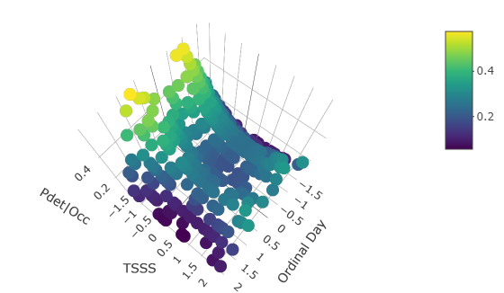

### Figure 13. Predicted boom detection probability given occupancy at a site varying with TSSS, ordinal day, and moon illumination for CONI with 20 visits/site and 600 seconds/visit. Top detection model: Ordinal day (β=10.40, 95% LCL=2.14, 95% UCL=18.66); Ordinal day2 (β=-10.52, 95% LCL=-18.85, 95% UCL=-2.18); Latitude (β=0.32, 95% LCL=0.02, 95% UCL=0.61).

When there were 20 15-minute visits per site, probability of boom detection given occupancy was highest at intermediate values of ordinal day (i.e. mid-season), and highest at lower and higher values of TSSS (i.e. closer to sunset and sunrise), but the effect of TSSS varied with latitude. At higher latitudes, boom detection probability declined with increasing TSSS. Detection of booms increased slightly with increasing moon illumination (Figure 14).

 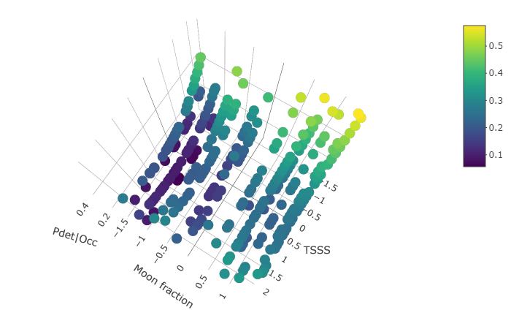

### Figure 14. Predicted boom detection probability given occupancy at a site varying with TSSS, ordinal day, and moon illumination for CONI with 20 visits/site and 900 seconds/visit. Top detection model: TSSS (β=-1.02, 95% LCL=-1.92, 95% UCL=-0.12); TSSS2 (β=0.79, 95% LCL=-0.16, 95% UCL=1.74); Ordinal day (β=7.92, 95% LCL=-0.89, 95% UCL=16.72); Ordinal day2 (β=-8.03, 95% LCL=-16.87, 95% UCL=0.81); Moon fraction (β=0.23, 95% LCL=-0.08, 95% UCL=0.55).

When there were 20 1-hour visits per site, probability of boom detection given occupancy decreased with increasing ordinal day (i.e. mid-season), and highest at lower and higher values of TSSS (i.e. closer to sunset and sunrise), but the effects of ordinal day and TSSS varied with latitude. Boom detection probability declined more strongly with increasing ordinal day and TSSS at higher latitudes. Detection of booms increased slightly with increasing moon illumination (Figure 15).

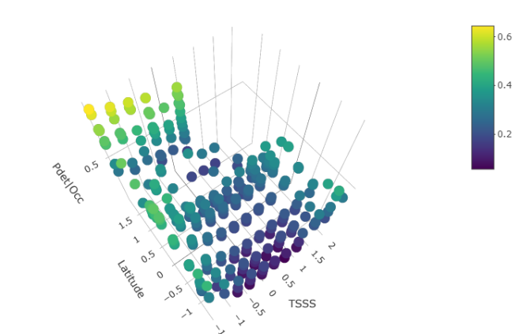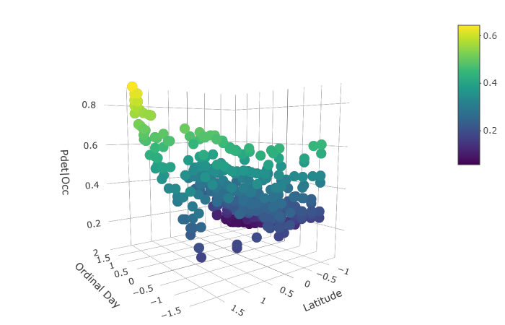

### Figure 15. Predicted boom detection probability given occupancy at a site varying with TSSS, ordinal day, and moon illumination for CONI with 20 visits/site and 3600 seconds/visit. Top detection model: TSSS (β=-3.88, 95% LCL=-10.83, 95% UCL=3.07); TSSS2 (β=4.17, 95% LCL=-3.17, 95% UCL=11.50); Latitude (β=-3.88, 95% LCL=-7.19, 95% UCL=-0.58); TSSS*Latitude (β=2.69, 95% LCL=-3.96, 95% UCL=9.34); TSSS2*Latitude (β=-3.03, 95% LCL=-10.16, 95% UCL=4.09); Ordinal day (β=-3.89, 95% LCL=-6.99, 95% UCL=0.79); Ordinal day*Latitude (β=5.06, 95% LCL=1.17, 95% UCL=8.95); Moon fraction (β=0.07, 95% LCL=-0.19, 95% UCL=0.35).

## Assessing Peent Activity Rates with Generalized Additive Mixed Models

Peent activity rates were higher at sites > 55 degrees N. As the visit durations that I examined increased, the number of peents counted per visit increased and the number of peents predicted per visit also increased. Predicted counts were generally negligible at sites < 55 degrees N except for GAMMs for the 1-hour visits.

When there were 20 3-minute visits per site, peent activity rates varied with ordinal day and TSSS according to latitude. Above 55 degrees N, peent activity rates were highest at sunset and 160-170 days after January 1. Below 55 degrees N, peent activity rates were highest 160 days after January 1 and at sunset and 20000 seconds after sunset, but were negligible (Figure 16).

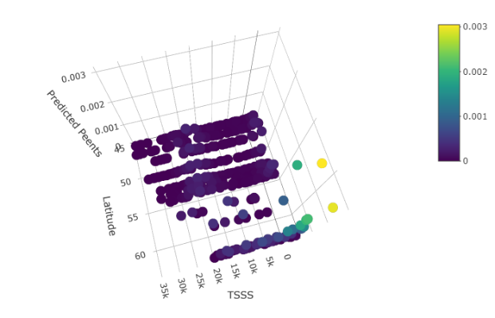 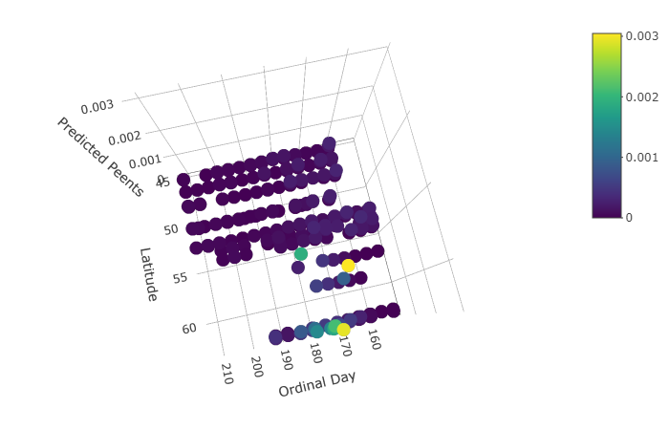

### Figure 16. Predicted CONI peent activity rates (counts per interval) with 20 visits/site and 180 seconds/visit. Generalized additive mixed model: latgroupN (“N”≥55, “S”<55) + (TSSS, knots = 4, basis = "cubic spline", by=latgroupN) + (TSSS, knots = 4, basis = "cubic spline", by=latgroupN) (β= -8.00 [Intercept]; -2.98 [latgroupN]; 5.72 [ordinal.s:latgroupNN.1]; 1.81 [ordinal.s:latgroupNN.2]; 11.80 [ordinal.s:latgroupNN.3]; -0.21 [ordinal.s:latgroupNS.1]; -1.28 [ordinal.s:latgroupNS.2]; -0.87 [ordinal.s:latgroupNS.3]; -0.95 [TSSS.s:latgroupNN.1]; -1.32 [TSSS.s:latgroupNN.2]; -0.44 [TSSS.s:latgroupNN.3]; -2.11 [TSSS.s:latgroupNS.1]; 0.67 [TSSS.s:latgroupNS.2]; -10.63 [TSSS.s:latgroupNS.3]).

When there were 20 6-minute visits per site, peent activity rates varied with ordinal day and TSSS according to latitude. Above 55 degrees N, peent activity rates were highest at sunset and 165 days after January 1, but were still negligible. Below 55 degrees N, peent activity rates were virtually zero regardless of ordinal day or TSSS (Figure 17).

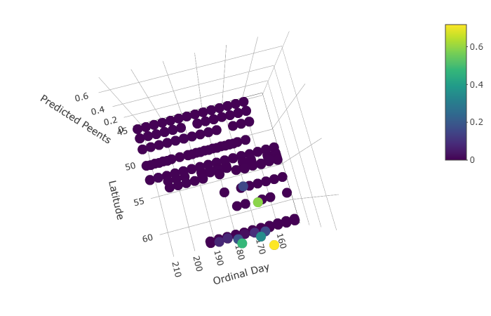 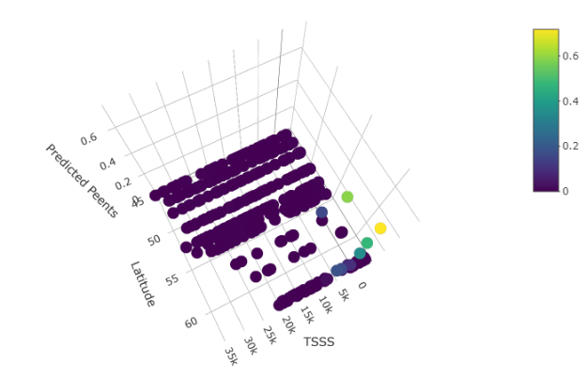

### Figure 17. Predicted CONI peent activity rates (counts per interval) with 20 visits/site and 360 seconds/visit. Generalized additive mixed model: latgroupN (“N”≥55, “S”<55) + (TSSS, knots = 4, basis = "cubic spline", by=latgroupN) + (TSSS, knots = 4, basis = "cubic spline", by=latgroupN) (β= -66.32 [Intercept]; 58.80 [latgroupN]; 9.10 [ordinal.s:latgroupNN.1]; 2.83 [ordinal.s:latgroupNN.2]; -8.48 [ordinal.s:latgroupNN.3]; -0.27 [ordinal.s:latgroupNS.1]; 0.52 [ordinal.s:latgroupNS.2]; 0.84 [ordinal.s:latgroupNS.3]; 29.01 [TSSS.s:latgroupNN.1]; -70.82 [TSSS.s:latgroupNN.2]; -179.07 [TSSS.s:latgroupNN.3]; -2.27 [TSSS.s:latgroupNS.1]; 0.02 [TSSS.s:latgroupNS.2]; -1.79 [TSSS.s:latgroupNS.3]).

When there were 20 10-minute visits per site, peent activity rates varied with ordinal day and TSSS according to latitude. Above 55 degrees N, peent activity rates were highest at sunset and 180 days after January 1, but were still negligible. Below 55 degrees N, peent activity rates were virtually zero regardless of ordinal day or TSSS (Figure 18).

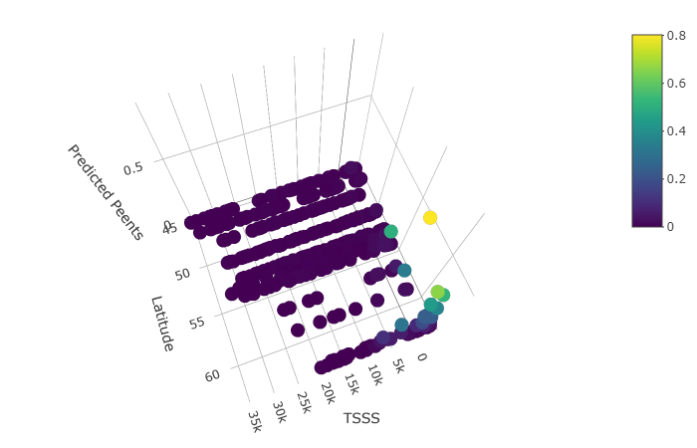 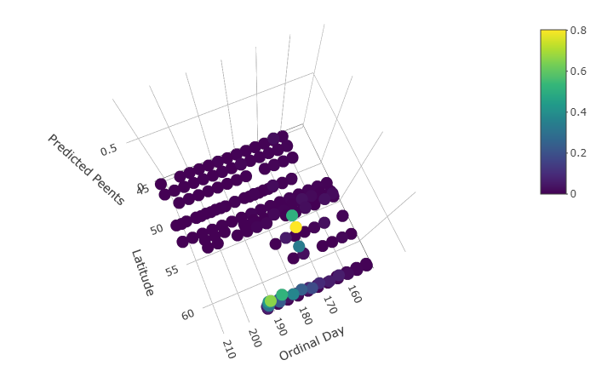

### Figure 18. Predicted CONI peent activity rates (counts per interval) with 20 visits/site and 600 seconds/visit. Generalized additive mixed model: latgroupN (“N”≥55, “S”<55) + (TSSS, knots = 4, basis = "cubic spline", by=latgroupN) + (TSSS, knots = 4, basis = "cubic spline", by=latgroupN) (β= -30.49 [Intercept]; 23.27 [latgroupN]; 3.77 [ordinal.s:latgroupNN.1]; 1.94 [ordinal.s:latgroupNN.2]; -14.24 [ordinal.s:latgroupNN.3]; -0.79 [ordinal.s:latgroupNS.1]; -2.16 [ordinal.s:latgroupNS.2]; -3.33 [ordinal.s:latgroupNS.3]; 9.23 [TSSS.s:latgroupNN.1]; -36.52 [TSSS.s:latgroupNN.2]; -89.79 [TSSS.s:latgroupNN.3]; -1.75 [TSSS.s:latgroupNS.1]; -0.79 [TSSS.s:latgroupNS.2]; -7.50 [TSSS.s:latgroupNS.3]).

When there were 20 15-minute visits per site, peent activity rates varied with ordinal day and TSSS according to latitude. Above 55 degrees N, peent activity rates were highest at sunset and in the first 2 hours after sunset and 180 days after January 1. Below 55 degrees N, peent activity rates were similarly related to ordinal day or TSSS but were predicted to be negligible (Figure 19).

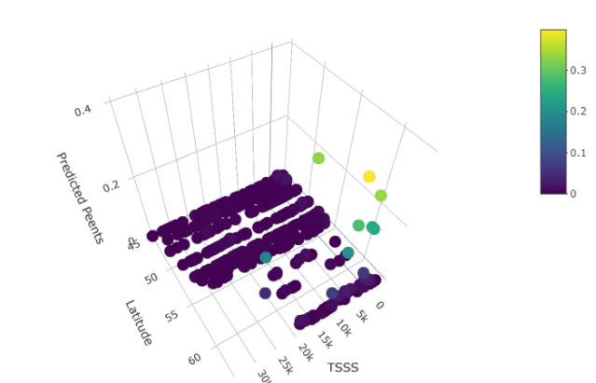 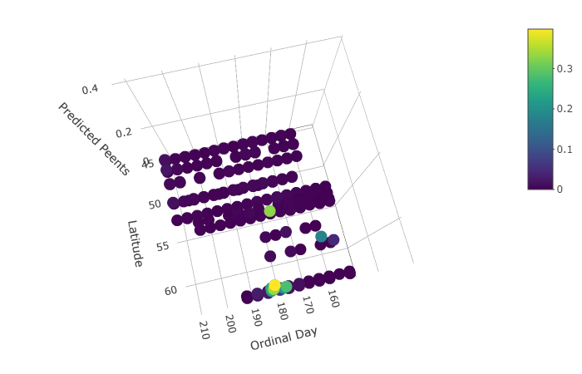

### Figure 19. Predicted CONI peent activity rates (counts per interval) with 20 visits/site and 900 seconds/visit. Generalized additive mixed model: latgroupN (“N”≥55, “S”<55) + (TSSS, knots = 4, basis = "cubic spline", by=latgroupN) + (TSSS, knots = 4, basis = "cubic spline", by=latgroupN) (β= -13.75 [Intercept]; 6.80 [latgroupN]; 10.01 [ordinal.s:latgroupNN.1]; 1.09 [ordinal.s:latgroupNN.2]; -115.37 [ordinal.s:latgroupNN.3]; 1.08 [ordinal.s:latgroupNS.1]; -0.28 [ordinal.s:latgroupNS.2]; 1.53 [ordinal.s:latgroupNS.3]; 0.12 [TSSS.s:latgroupNN.1]; 3.55 [TSSS.s:latgroupNN.2]; 94.87 [TSSS.s:latgroupNN.3]; -1.78 [TSSS.s:latgroupNS.1]; 0.23 [TSSS.s:latgroupNS.2]; -6.59 [TSSS.s:latgroupNS.3]).

When there were 20 1-hour visits per site, peent activity rates varied with ordinal day and TSSS according to latitude. Above 55 degrees N, peent activity rates were highest about an hour after sunset and 180 days after January 1. Below 55 degrees N, peent activity rates were highest before sunset and around sunrise and 170 days after January 1 (Figure 20).

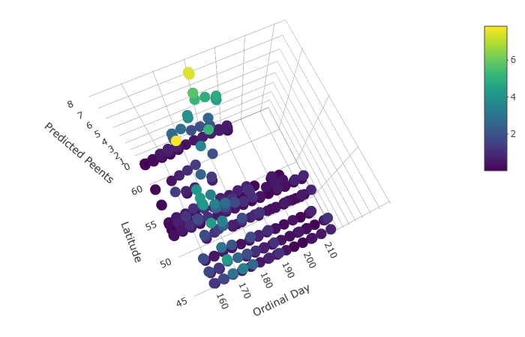 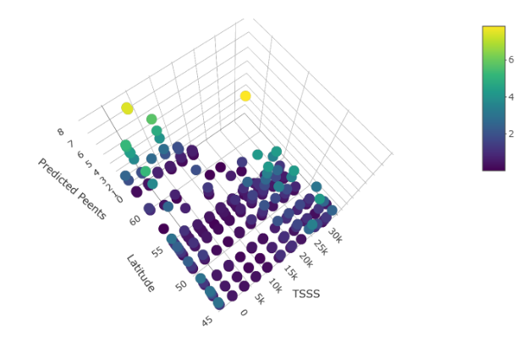

### Figure 20. Predicted CONI peent activity rates (counts per interval) with 20 visits/site and 3600 seconds/visit. Generalized additive mixed model: latgroupN (“N”≥55, “S”<55) + (TSSS, knots = 4, basis = "cubic spline", by=latgroupN) + (TSSS, knots = 4, basis = "cubic spline", by=latgroupN) (β= -0.87 [Intercept]; -0.08 [latgroupN]; 3.96 [ordinal.s:latgroupNN.1]; -0.03 [ordinal.s:latgroupNN.2]; -20.68 [ordinal.s:latgroupNN.3]; 1.36 [ordinal.s:latgroupNS.1]; -0.87 [ordinal.s:latgroupNS.2]; 0.17 [ordinal.s:latgroupNS.3]; -0.57 [TSSS.s:latgroupNN.1]; -0.53 [TSSS.s:latgroupNN.2]; 28.04 [TSSS.s:latgroupNN.3]; -1.66 [TSSS.s:latgroupNS.1]; 0.82 [TSSS.s:latgroupNS.2]; 0.21 [TSSS.s:latgroupNS.3]).

## Assessing Boom Activity Rates with Generalized Additive Mixed Models

When there were 20 3-minute visits per site, above 55 degrees N, boom activity rates were fairly constant from sunset to an hour before sunrise before dropping off, and varied quadratically with ordinal day, being highest around 170 days after January 1. Below 55 degrees N, boom activity rates were highest at sunset and secondarily around sunrise, and were highest earlier in the season 150-160 days after January 1 (Figure 21).

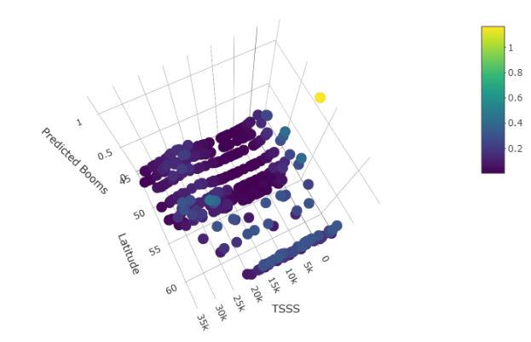 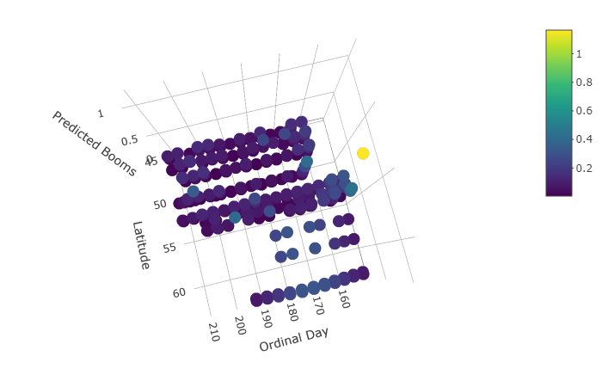

### Figure 21. Predicted CONI boom activity rates (counts per interval) with 20 visits/site and 180 seconds/visit. Generalized additive mixed model: latgroupN (“N”≥55, “S”<55) + (TSSS, knots = 4, basis = "cubic spline", by=latgroupN) + (TSSS, knots = 4, basis = "cubic spline", by=latgroupN) (β= -2.20 [Intercept]; -1.25 [latgroupN]; 1.24 [ordinal.s:latgroupNN.1]; -0.84 [ordinal.s:latgroupNN.2]; -2.69 [ordinal.s:latgroupNN.3]; -1.22 [ordinal.s:latgroupNS.1]; -0.39 [ordinal.s:latgroupNS.2]; -0.38 [ordinal.s:latgroupNS.3]; 0.00 [TSSS.s:latgroupNN.1]; 0.00 [TSSS.s:latgroupNN.2]; 0.00 [TSSS.s:latgroupNN.3]; -3.39 [TSSS.s:latgroupNS.1]; -0.34 [TSSS.s:latgroupNS.2]; -1.04 [TSSS.s:latgroupNS.3]).

When there were 20 6-minute visits per site, above 55 degrees N, boom activity rates were highest at sunset and 160 days after January 1. Below 55 degrees N, boom activity rates were highest at sunset and 180 days after January 1 (Figure 22).

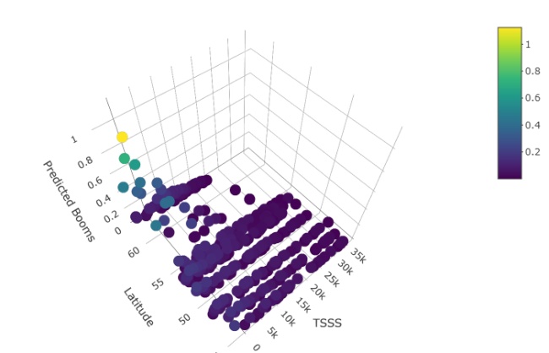 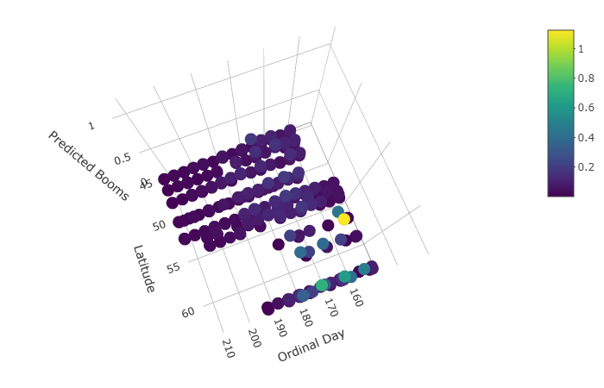

### Figure 22. Predicted CONI boom activity rates (counts per interval) with 20 visits/site and 360 seconds/visit. Generalized additive mixed model: latgroupN (“N”≥55, “S”<55) + (TSSS, knots = 4, basis = "cubic spline", by=latgroupN) + (TSSS, knots = 4, basis = "cubic spline", by=latgroupN) (β= -5.50 [Intercept]; 2.25 [latgroupN]; 2.69 [ordinal.s:latgroupNN.1]; -1.91 [ordinal.s:latgroupNN.2]; -7.17 [ordinal.s:latgroupNN.3]; 1.02 [ordinal.s:latgroupNS.1]; -0.23 [ordinal.s:latgroupNS.2]; -1.61 [ordinal.s:latgroupNS.3]; -1.15 [TSSS.s:latgroupNN.1]; -3.07 [TSSS.s:latgroupNN.2]; -4.44 [TSSS.s:latgroupNN.3]; -0.33 [TSSS.s:latgroupNS.1]; -0.87 [TSSS.s:latgroupNS.2]; -1.27 [TSSS.s:latgroupNS.3]).

When there were 20 10-minute visits per site, above 55 degrees N, boom activity rates were not strongly related to TSSS and 170 days after January 1. Below 55 degrees N, boom activity rates were highest before sunrise and 160 days after January 1 (Figure 23).

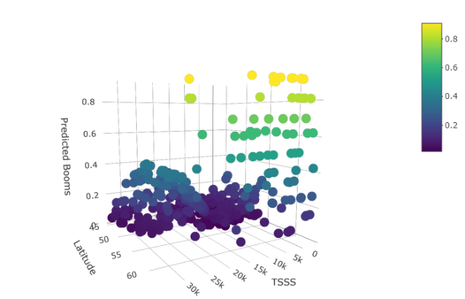 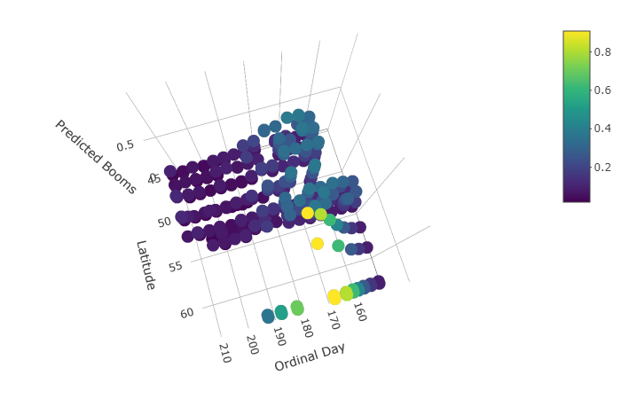

### Figure 23. Predicted CONI boom activity rates (counts per interval) with 20 visits/site and 600 seconds/visit. Generalized additive mixed model: latgroupN (“N”≥55, “S”<55) + (TSSS, knots = 4, basis = "cubic spline", by=latgroupN) + (TSSS, knots = 4, basis = "cubic spline", by=latgroupN) (β= -1.05 [Intercept]; -1.28 [latgroupN]; 1.79 [ordinal.s:latgroupNN.1]; 0.28 [ordinal.s:latgroupNN.2]; -1.38 [ordinal.s:latgroupNN.3]; 0.15 [ordinal.s:latgroupNS.1]; -0.88 [ordinal.s:latgroupNS.2]; -0.60 [ordinal.s:latgroupNS.3]; -0.00 [TSSS.s:latgroupNN.1]; -0.00 [TSSS.s:latgroupNN.2]; -0.00 [TSSS.s:latgroupNN.3]; -1.00 [TSSS.s:latgroupNS.1]; 0.49 [TSSS.s:latgroupNS.2]; -0.17 [TSSS.s:latgroupNS.3]).

When there were 20 15-minute visits per site, above 55 degrees N, boom activity rates were highest sunset, decreased with increasing TSSS, and were highest around 160-170 days after January 1. Below 55 degrees N, boom activity rates were highest at sunset and secondarily before sunrise and 160 days after January 1 (Figure 24).

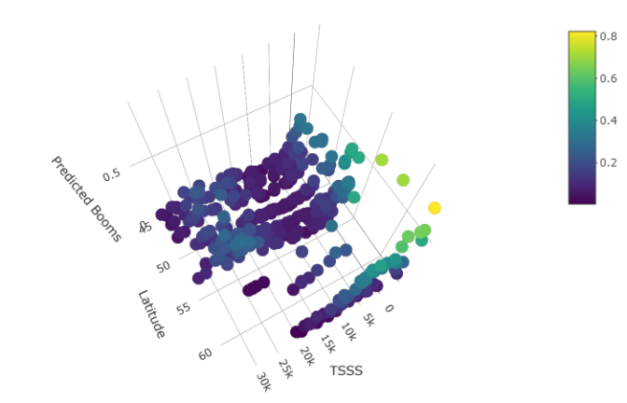 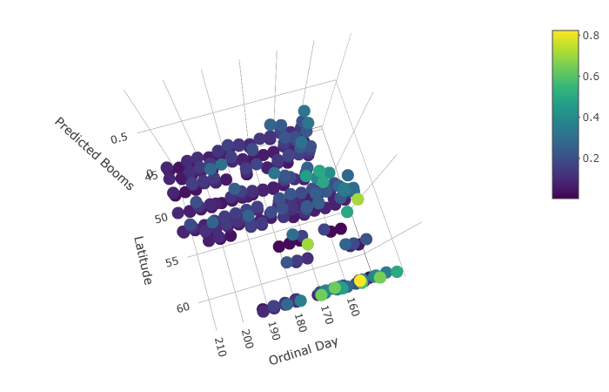

### Figure 24. Predicted CONI boom activity rates (counts per interval) with 20 visits/site and 900 seconds/visit. Generalized additive mixed model: latgroupN (“N”≥55, “S”<55) + (TSSS, knots = 4, basis = "cubic spline", by=latgroupN) + (TSSS, knots = 4, basis = "cubic spline", by=latgroupN) (β= -3.26 [Intercept]; 0.96 [latgroupN]; 0.87 [ordinal.s:latgroupNN.1]; -1.14 [ordinal.s:latgroupNN.2]; -3.29 [ordinal.s:latgroupNN.3]; -0.13 [ordinal.s:latgroupNS.1]; -0.38 [ordinal.s:latgroupNS.2]; -0.61 [ordinal.s:latgroupNS.3]; -0.62 [TSSS.s:latgroupNN.1]; -2.13 [TSSS.s:latgroupNN.2]; -3.64 [TSSS.s:latgroupNN.3]; -1.61 [TSSS.s:latgroupNS.1]; 0.11 [TSSS.s:latgroupNS.2]; -0.86 [TSSS.s:latgroupNS.3]).

When there were 20 1-hour visits per site, above 55 degrees N, boom activity rates were highest sunset, decreased with increasing TSSS, and were highest around 160-170 days after January 1. Below 55 degrees N, boom activity rates were highest at sunset and secondarily before sunrise and 160 days after January 1 (Figure 25).

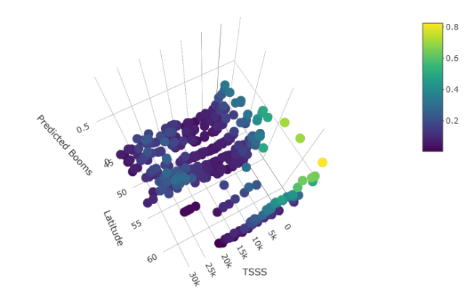 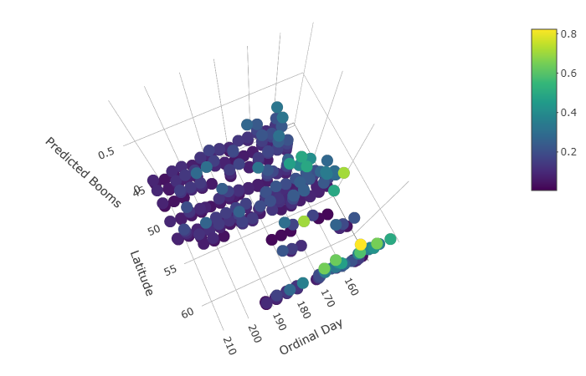

### Figure 25. Predicted CONI boom activity rates (counts per interval) with 20 visits/site and 3600 seconds/visit. Generalized additive mixed model: latgroupN (“N”≥55, “S”<55) + (TSSS, knots = 4, basis = "cubic spline", by=latgroupN) + (TSSS, knots = 4, basis = "cubic spline", by=latgroupN) (β= 1.17 [Intercept]; -1.56 [latgroupN]; 0.91 [ordinal.s:latgroupNN.1]; -0.33 [ordinal.s:latgroupNN.2]; -2.33 [ordinal.s:latgroupNN.3]; -0.36 [ordinal.s:latgroupNS.1]; -0.16 [ordinal.s:latgroupNS.2]; -0.76 [ordinal.s:latgroupNS.3]; -0.53 [TSSS.s:latgroupNN.1]; -0.65 [TSSS.s:latgroupNN.2]; 29.46 [TSSS.s:latgroupNN.3]; -1.05 [TSSS.s:latgroupNS.1]; 0.56 [TSSS.s:latgroupNS.2]; -1.50 [TSSS.s:latgroupNS.3]).

# Discussion

## Recommended Number of Survey Visits and Length of Surveys

If CONI data are collected so as to run occupancy models on the data, my analyses suggest that increasing both number of visits per site and the duration of visits will increase the probability that any present CONI are detected; however, model predictive power may not improve or may even worsen with an increased number of visits. My analyses suggested that accuracy of predicting joint probability of detection, as measured by area-under-the-curve, dropped sharply when there were more than 4 visits per site, whether I was analyzing detection of peents or booms. It should be noted that in these analyses I focused entirely on detection covariates without modelling site-specific occupancy, so it might have been possible to improve prediction accuracy by including site covariates. However, the study was not specifically designed to be analyzed by occupancy models, since CONI were detected at most of the sites in 2014.

Further, the use of continuously recorded ARU data to construct my simulated visits potentially gave me a much larger number of sample visits per site than is usually available to occupancy modelling studies. It is possible that some assumptions of occupancy modelling may break down with a very large number of visits. I ran occupancy models using visits over a two-month period. This period might be short enough to assume population closure, since I focused on detection covariates rather than occupancy covariates. However, CONI were only detected booming on a single day of visits at one of the sites. While it is possible that at that site, the CONI could have settled down to breed within 4 days of that date, it is also possible that CONI may have simply moved on from that site after a single boom-recording date, in which case the assumption of population closure was violated at that site. Multi-season occupancy models could have been used to relax the assumption of population closure. I used single-season occupancy models because I focused on detection rather than occupancy covariates.

Another related issue with how a large number of survey visits could cause occupancy model assumptions to fail is that if individual CONI are just passing through a site, a single visit with a detection out of a large number of visits will result in an extremely low estimated probability of detection given occupancy, and consequently an overestimated probability of occupancy. The percentage of sites where CONI are predicted to occur will then be overestimated, which could have serious implications for conservation if CONI are then mistakenly assessed as being at lower risk.

Reducing the number of visits per site to just 3-4 per season – the minimum recommended number visits for occupancy models – could reduce the amount of time spent processing data from each site, potentially enabling a larger number of sites to be visited using ARUs. In doing so, studies could potentially increase the inference of their results by covering a wider variety of conditions (e.g. nighthawk habitats) for the same amount of processing time outside of field work. Alternatively, instead of increasing the number of sites, researchers could use the processing time liberated by having fewer visits to increase the duration of recordings examined at each site. Given that visit duration was a stronger predictor than number of visits of both peent and boom detection probability, investing in longer recordings rather than more recordings is probably more likely to result in more detections of cryptic species.

## Recommended Timing of CONI Surveys Within Season and Night

My analyses suggested that aside from increasing the number and/or duration of visits, both activity rates and probability of detection of CONI would be maximized by conducting surveys at or shortly after sunset, with point counts at sunrise generally being a second choice. CONI surveys should preferably be conducted from June 9 to June 29 when this species is more likely to be detected and is most frequently booming and calling.

Temperature and moonlight had weaker effects. When temperature occurred in top occupancy models as an effect, probability of peent detection increased with mean nightly temperature, possibly because warmer nights were associated with increased insect activity. Alternatively, CONI might have entered torpor on the coldest nights, though this possibility is questionable (Fletcher et al. 2004). Mean nightly temperature varied from 10.4 – 21.4 ° C. on nights that had temperature data taken. In contrast to temperature, peent and boom detection probabilities had contrasting relationships with respect to moonlight. As moon illumination increased, probability of detecting peents declined while probability of detecting booms increased slightly. If the intent of surveys is to establish evidence of breeding, nighthawk surveys should be scheduled when moonlight is waxing or full.

## Comparing Repeated Survey Protocols to BBS Protocols With Respect to CONI Detection

Point counts within the BBS consist of 50 stops along a 39.4 km roadside route (an average of 788 m apart). At these stops, observers count all birds of all species seen and heard within a 3-minute period. Each point count is surveyed on a single visit per year (Sauer et al. 1994). Our occupancy model results indicate that the length of BBS visits is probably too short to detect many CONI that are present at a site, since detection probability in my analyses increased with visit duration and did not reach an asymptote with the durations I analyzed. Further, the probability of detecting CONI that are present will be low with a single visit, since I found that 12-20 visits were required before the proportion of sites with detections reached an asymptote.

Point counts within the BBS are tailored to detect as many species of birds as possible. Given that most species are songbirds, such point counts occur during the daytime when songbird species are most likely to be singing. My occupancy models and GAMMs suggest that CONI are more likely to be detected and peent-calling and/or booming more often around sunset, with a smaller secondary peak in activity around sunrise. While some CONI may be detected in early daytime point counts at sunrise, the BBS might increase the number of detections of this species for analyses by collecting point counts at sunset, especially in areas that are likely to be suitable CONI habitats (roadside areas with sand, gravel, and rocky outcrops, or roadsides passing through recently burned or logged areas). Since BBS point counts within a BBS route occur closer to each other than the distance between sites in the CWS-ON CONI study, BBS points selected for additional sunset surveys should be further apart than 788 m to reduce double-counting of CONI.

Apart from TSSS, the most important variable influencing detection probability of CONI was ordinal day. CONI were generally most likely to be detected in occupancy models from 160-180 days since January 1 (June 9-June 29). Peent and boom activity rates were also generally highest within this window of time. Additional point counts tailored towards the collection of CONI data at sunset should be concentrated within this 2-3 week period.

Although TSSS and ordinal day were the primary detection variables, the BBS is used to establish evidence of breeding in bird species; therefore, detection of breeding evidence in CONI in the BBS’s point counts might be increased slightly by conducting surveys on nights with greater moon illumination. However, the 3-minute point counts used in the BBS may be too short for moon illumination to be useful, since moonlight was only a factor in the top models for data sets with longer visit durations.

# Citations

Agafonkin, V., & Thieurmel, B. (2017). suncalc: Compute sun position, sunlight phases, moon position, and lunar phase. R package version 0.3.

Barton, K., & Barton, M. K. (2019). Package ‘MuMIn’. R package version, 1(6).

Brigham, R. M., Ng, J., Poulin, R. G., & Grindal, S. D. (2011). Common Nighthawk (*Chordeiles minor*). In A. Poole, editor. The Birds of North America Online. Cornell Lab of Ornithology, Ithaca, NY, USA.

Burnham, K. P., & Anderson, D. R. (2004). Multimodel inference: understanding AIC and BIC in model selection. Sociological methods & research, 33(2), 261-304.

Buxton, R. T., & Jones, I. L. (2012). Measuring nocturnal seabird activity and status using acoustic recording devices: applications for island restoration. Journal of Field Ornithology, 83(1), 47-60.

Caccamise, D. F. (1974). Competitive relationships of the Common and Lesser Nighthawks. Condor, 76(1), 1-20.

Canaday, C. (1997) Loss of insectivorous birds along a gradient of human impact in Amazonia. Biological Conservation, 77, 63-77.

Charif, R. A., Waack, A. M., & Strickman, L. M. (2010). Raven Pro 1.4 User's Manual. Cornell Lab of Ornithology, Ithaca, NY. 367 pp.

Fiske, I., & Chandler, R. (2011). Unmarked: an R package for fitting hierarchical models of wildlife occurrence and abundance. Journal of statistical software, 43(10), 1-23.

Fletcher, Q. E., Fisher, R. J., Willis, C. K., & Brigham, R. M. (2004). Free-ranging common nighthawks use torpor. Journal of Thermal Biology, 29(1), 9-14.

Frommolt, K. H., & Tauchert, K. H. (2014). Applying bioacoustic methods for long-term monitoring of a nocturnal wetland bird. Ecological Informatics, 21, 4-12.

Frommolt, K. H. (2017). Information obtained from long-term acoustic recordings: applying bioacoustic techniques for monitoring wetland birds during breeding season. Journal of Ornithology, 158(3), 659-668.

Grolemund, G., & Wickham, H. (2011). Dates and times made easy with lubridate. Journal of Statistical Software, 40(3), 1-25.

Hallman, C. A., R. P. B. Foppen, C. A. M. van Turnhout, H. de Kroon, and E. Jongejans (2014) Declines in insectivorous birds are associated with high neonicotinoid concentrations. Nature, 511(7509), 341.

Nebel, S., A. Mills, J. McCracken, and P. Taylor (2010). Declines of aerial insectivores in North America follow a geographic gradient. Avian Conservation and Ecology, 5(2).

Oppel, S., Hervias, S., Oliveira, N., Pipa, T., Silva, C., Geraldes, P., Goh, M., Immler, E. & McKown, M. (2014). Estimating population size of a nocturnal burrow-nesting seabird using acoustic monitoring and habitat mapping. Nature Conservation, 7, 1.

Paquette, S. R., F. Pelletier, D. Garant, and M. Bélisle (2014). Severe recent decrease of adult body mass in a declining insectivorous bird population. Proceedings of the Royal Society B, 281, 20140649.

Robin, X., Turck, N., Hainard, A., Tiberti, N., Lisacek, F., Sanchez, J. C., & Müller, M. (2011). pROC: an open-source package for R and S+ to analyze and compare ROC curves. BMC bioinformatics, 12(1), 77.

Rosenberg, K. V., Dokter, A. M., Blancher, P. J., Sauer, J. R., Smith, A. C., Smith, P. A., Stanton, J. C., Panjabi, A., Helft, L., Parr. M, & Marra, P. P. (2019). Decline of the North American avifauna. Science, 366(6461), 120-124.

Sauer, J. R., Peterjohn, B. G., & Link, W. A. (1994). Observer differences in the North American breeding bird survey. The Auk, 111(1), 50-62.

Sekercioglu, C. H., P. R. Ehrlich, G. C. Daily, D. Aygen, D. Goehring, and R. F. Sandi (2002) Disappearance of insectivorous birds from tropical forest fragments. Proceedings of the National Academy of Sciences, 99, 263-267.

Smith, A. C., M.-A. R. Hudson, C. M. Downes, and C. M. Francis (2015) Change points in the population trends of aerial-insectivorous birds in North America: synchronized in time across species and regions. PLOS One, 10(7): e0130768. doi:10.1371/journal.pone.0130768.

Sólymos, P. (2017). <https://cran.r-project.org/web/packages/intrval/intrval.pdf>.

Tegeler, A. K., Morrison, M. L., & Szewczak, J. M. (2012). Using extended‐duration audio recordings to survey avian species. Wildlife Society Bulletin, 36(1), 21-29.

Weller, M. W. (1958). Observations of the incubation behavior of a Common Nighthawk. Auk, 75(1), 48-59.Wood, S., Scheipl, F., & Wood, M. S. (2017). Package ‘gamm4’. Am. Stat., 45, 339.

# Abbreviations Used in This Report

ARU = Acoustic or Autonomous Recording Unit

BBS = North American Breeding Bird Survey

CONI = Common Nighthawk (*Chordeiles minor*)

TSSS = Time Since Sunset